Press here if you don’t have an account to go register in the website



Press here if you already have an account

‘

If the user presses on the signup option he will be taken to the register page which contain this registration form which contain the Name, Email, Password, Number, and Address sections that the user should filled with the user’s information

But if the name or email already exist in the database the page will refresh indicating that you can’t proceed with provided name or email

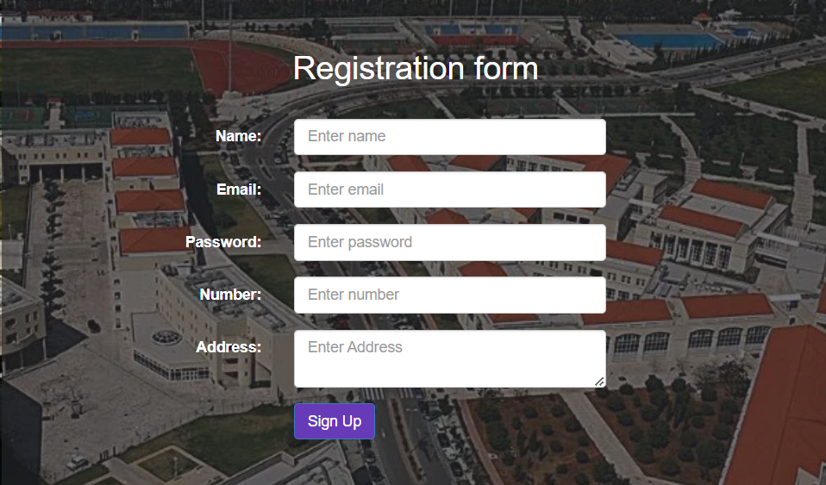

If the user presses on the login option it will take him to the login page where this form containing two sections that the user should provide in order to login to his account

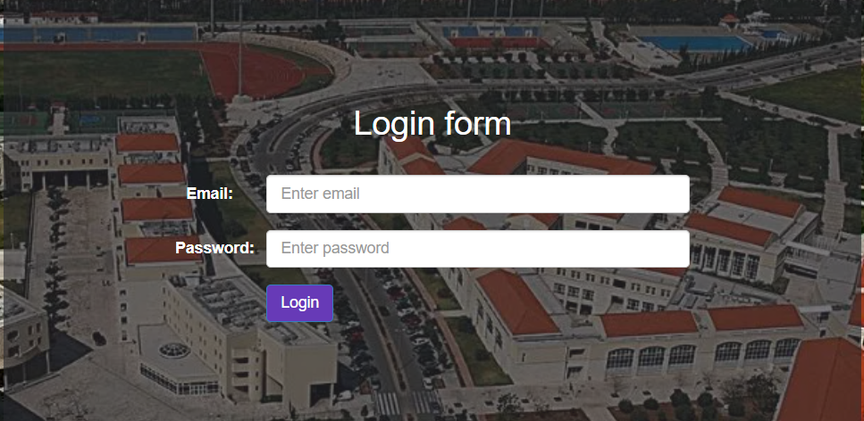

If the user provides invalid email or wrong password this pop up message will appear

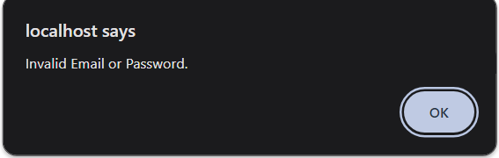

After you finish signing up or logging in you will be taken to the home page



If you press the open chat button you will be taken to the chat page where you will be able to chat with other students from the Lebanese University

And this is how it looks when there is no messages sent

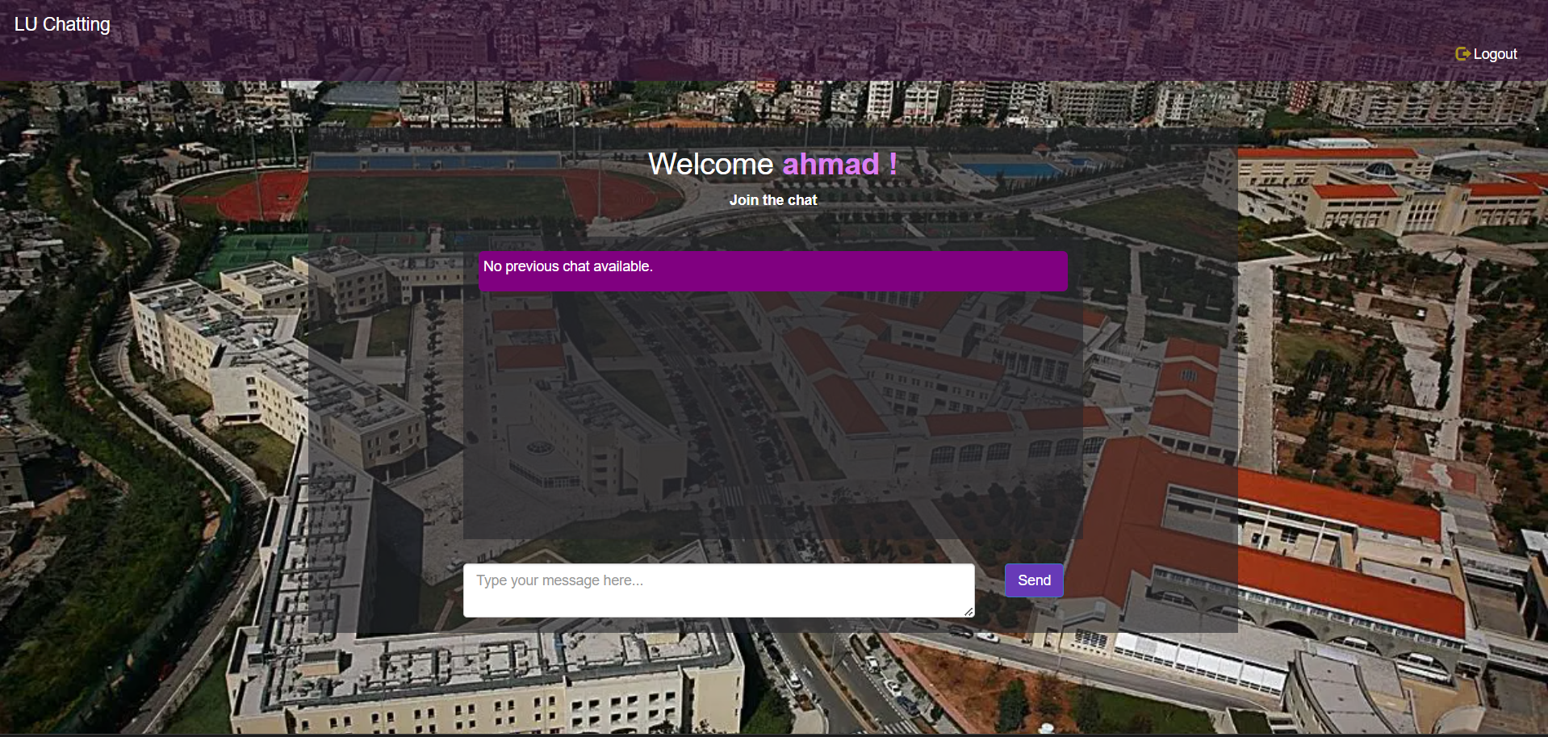

The user has to press this button to send the message into the group chat

This is where the user enters the message he wants to send

This is how it looks when there is at least 1 message sent to the group chat

Also, if the user tries to send messages containing NSFW words like “dumb” they will not be sent to the group chat and 10 points will be deducted from the trust given to him and if his trust drops under 30, will be banned forever

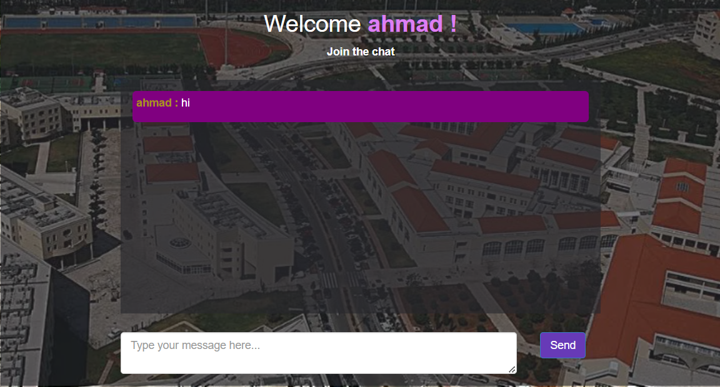

If you get to trust under 30 you will get this pop up message which will direct you to the login page after you press ok

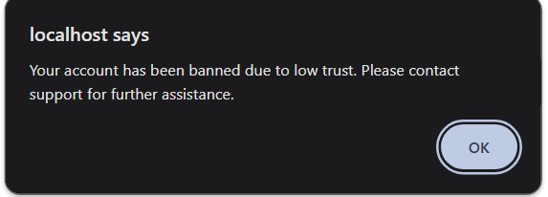

This is the pop up message that you will get if you try to login with a banned account

